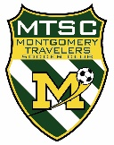
MONTGOMERY TRAVELERS SOCCER CLUB
How to Renew and Upload Certs for Administrators
UPDATED: 07/02/22 rjs
BACKGROUND: NJ State law requires that all coaches and administrators (volunteers) that have contact with youth, or have access to sensitive youth data such as contact info or birth dates, must be SafeSport certified each seasonal year (9/1 to 8/31) and undergo a criminal background check every other seasonal year. This includes: professional coaches, parent volunteer coaches, team managers, board members, and registrars. To obtain a NJYS Coach Pass, coaches must also have uploaded (one time) their coaching license and concussion cert.
HOW TO TAKE TRAINING AND GET SAFESPORT CERT:
To get your initial (90 minutes) or annual refresher (30 minutes) SafeSport cert, click here. Be sure to download your certificate when complete and save for your records.
HOW TO UPLOAD CERTS AND AUTHORIZE BACKGROUND CHECK:
You do this using your MTSC account (the same one you use to register your child(ren). Do this on a computer or tablet, NOT on a phone.
- Log into your MTSC account.
- On the left side, click
- At top right, click
- You’ll see a list of roles. Click on your role. (NOTE: you may need to scroll left or right to see it).
- Click on your name. If your name is not listed (for example, only your spouse is listed), click on at the top right and add your name as an authorized user. Then come back to this step.
- IMPORTANT: Scroll to the bottom of the page and click
- Enter (or correct) all of the information requested
- Upload a photo if one is not there already. This must be head-and-shoulders, no glasses or head covering, like a passport photo.
- Under “ACKNOWLEDGEMENT…” Click on the button, read and e-sign.
- Under “Coach Compliance…” Click on button, read, and e-sign. Do this EVEN IF YOU ARE NOT A COACH (dunno why).
- Click to upload your SafeSport Cert. NOTE: if you see “Document Verified” it was already transmitted to NJYS automatically and you can skip this.
- Leave and alone unless you want to get an NJYS Coach Pass. If uploaded in a prior year, your will see “Document Verified” and you can skip.
- IMPORTANT: Scroll to the bottom of the page and click
- Now you will see a status summary (note that “Risk Status” means Background Check):
- 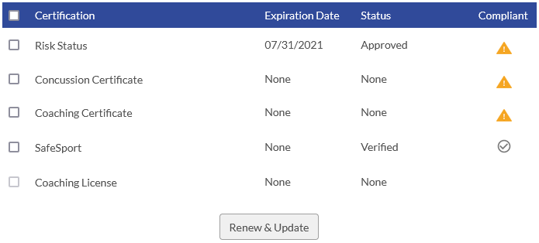
- Don’t worry about the details here if you followed the steps above.
  - Risk Status will change from Approved to Verified when NJYS completes the background check.
  - For SafeSport, if you uploaded the cert, it will change from Uploaded to Verified when NJYS staff looks at your cert and verifies it is valid. If it was automatically transmitted, it will say “Verified” here.
- You’re all done… THANKS! You can assume all is OK unless I contact you.

